Some widgets can handle one child and some can handle multiple.

Here, we will learn about a single child widget.

When we add color in the container() it thinks whole screen is its part and changes the color of the whole screen.

So, we must give some boundries to the container.

Step 1. Take the cursor on the container and press alt + enter, a drop down menu will appear.

Step 2. Select “wrap with new widget” from the list.

Step 3. Name that widget as “SafeArea”.

Step 4. Set height, width, margin (external boundaries) and padding (boundries of text inside the container)

Note: give numerical values in float point like 3.0,20.0 etc

Step 5: in margin use edgeinsect. Command which will show you other command in the list. Use the appropriate command from that list.

Code:

import 'package:flutter/material.dart';  
  
void main() => runApp(MyApp());  
  
class MyApp extends StatelessWidget {  
 @override  
 Widget build(BuildContext context) {  
 return MaterialApp(  
 home: Scaffold(  
 backgroundColor: Colors.*teal*,  
 body: SafeArea(  
 child: Container(  
 color: Colors.*green*,  
 height: 100.0,  
 width: 100.0,  
 margin: EdgeInsets.symmetric(  
 vertical: 250.0,  
 horizontal: 150.0,  
 ),  
 padding: EdgeInsets.all(30),  
 child: Text('Abdullah'),  
 ),  
 ),  
 ),  
 );  
 }  
}

result:

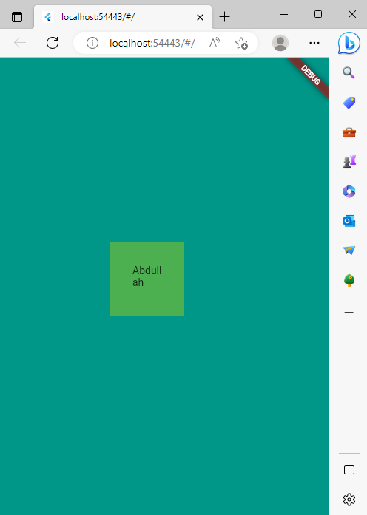

Another code:

Container(  
 margin: EdgeInsets.all(10.0),  
 decoration: BoxDecoration(  
 color: Color(0xFF1D1E33),  
 borderRadius: BorderRadius.circular(10.0),  
 ),  
),